User Manual for Implementation of Robotic Process Automation using UiPath solution at ICICI Pvt Ltd

Automating Dump Download Process

Contents

1 Introduction 1

2 Prerequisites 3

3 Orchestrator 5

3.1 Orchestrator Assets 5

4 How to run the bot 7

5 Bot Configuration File 9

6 Files in Shared Folder 10

7 Check for the input files 10

8 Logging in to ICore Portal 10

9 Extracting the details from Icore using “HACLINQ” Code 11

10 Send Outlook Mail 11

11 Known Issues 11

# Introduction

This document is a user manual for the – Automating Dump Download Process bot. The content of this document includes all the necessary information needed to know before using the bot.

The process is having one bot –

1. **Dump Download** –

In this process, the bot captures the transactions for each Account ID present in the input file, which will be placed by business users.

The bot opens the “ICORE” portal in the Edge and gives message box to enter credentials and OTP. Once the user logs into the portal successfully and click OK on the message box, bot navigates to HACLINQ menu option. In which, the bot will fill the necessary fields and clicks on “Go”. Then bot captures the data available from each page and add it in the output file. Then sends the mail with output attachment.

Bot does the above process for each Account ID available in the input file and send the status of all the Account IDs, along with the successful completion mail.

# Prerequisites

**Ms Excel**

1. **Ms Excel application must be installed in the machine.**
2. **In File > Options > Trust Centre > Trust Centre Settings > Protected View**

**Uncheck the “Enable Protected View Option”**

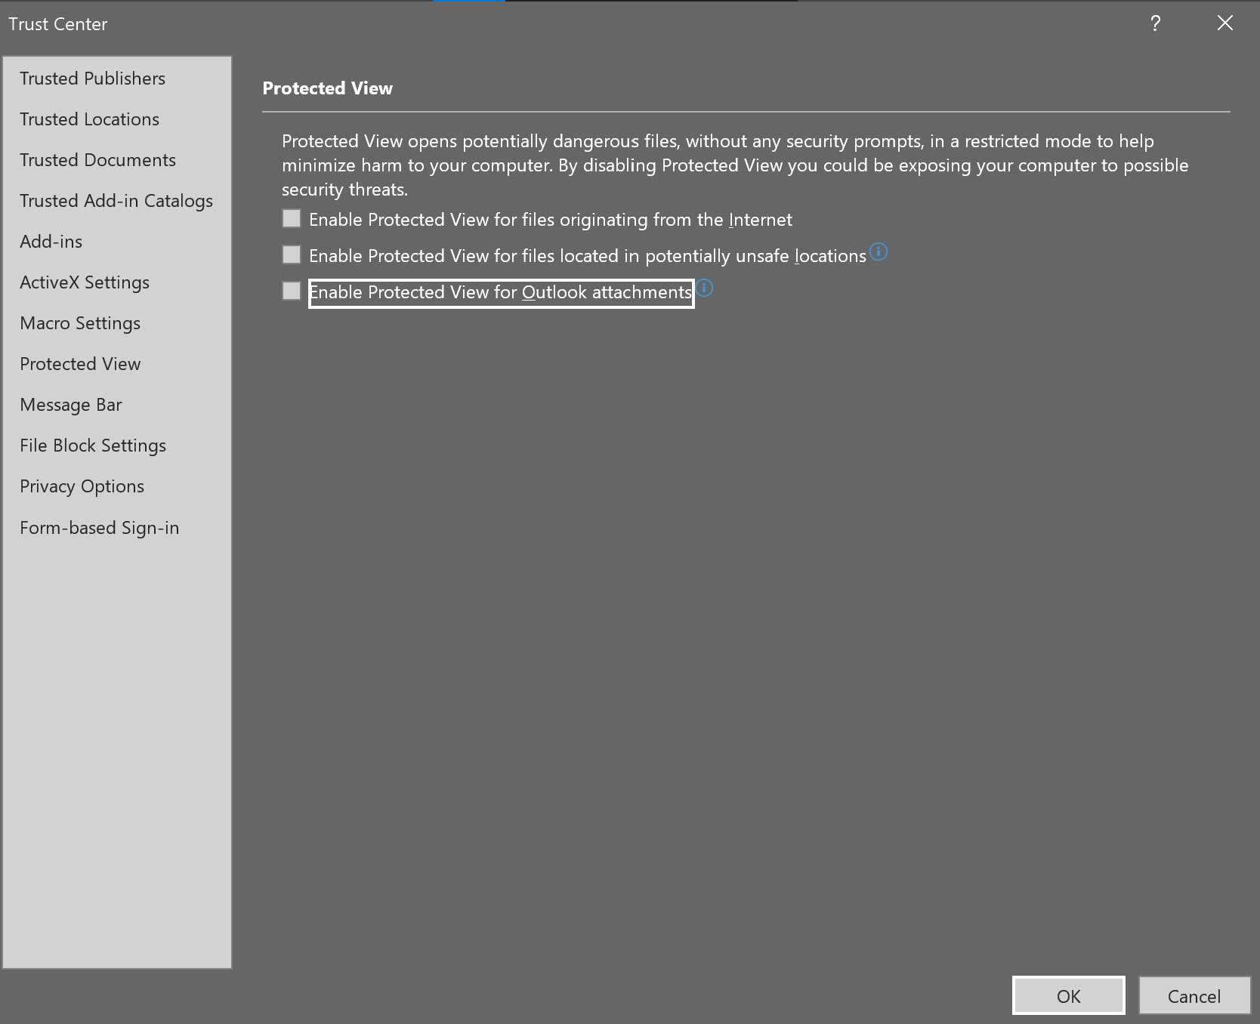

1. **In File > Options > Trust Centre > Trust Centre Settings > Trusted Locations > Add new location**

**Add the Shared folder path in the trusted location and check the “Subfolders of this location are also trusted”**

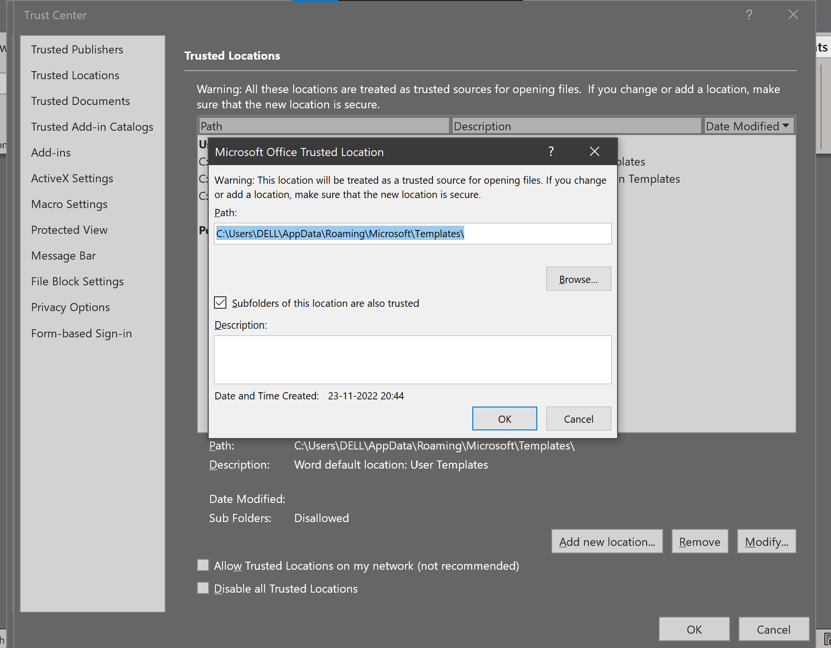

**MS Edge**

1. **Ms Edge must be installed in the machine.**
2. **In Settings > Downloads**

**Enable the “Ask me what to do with each download”**

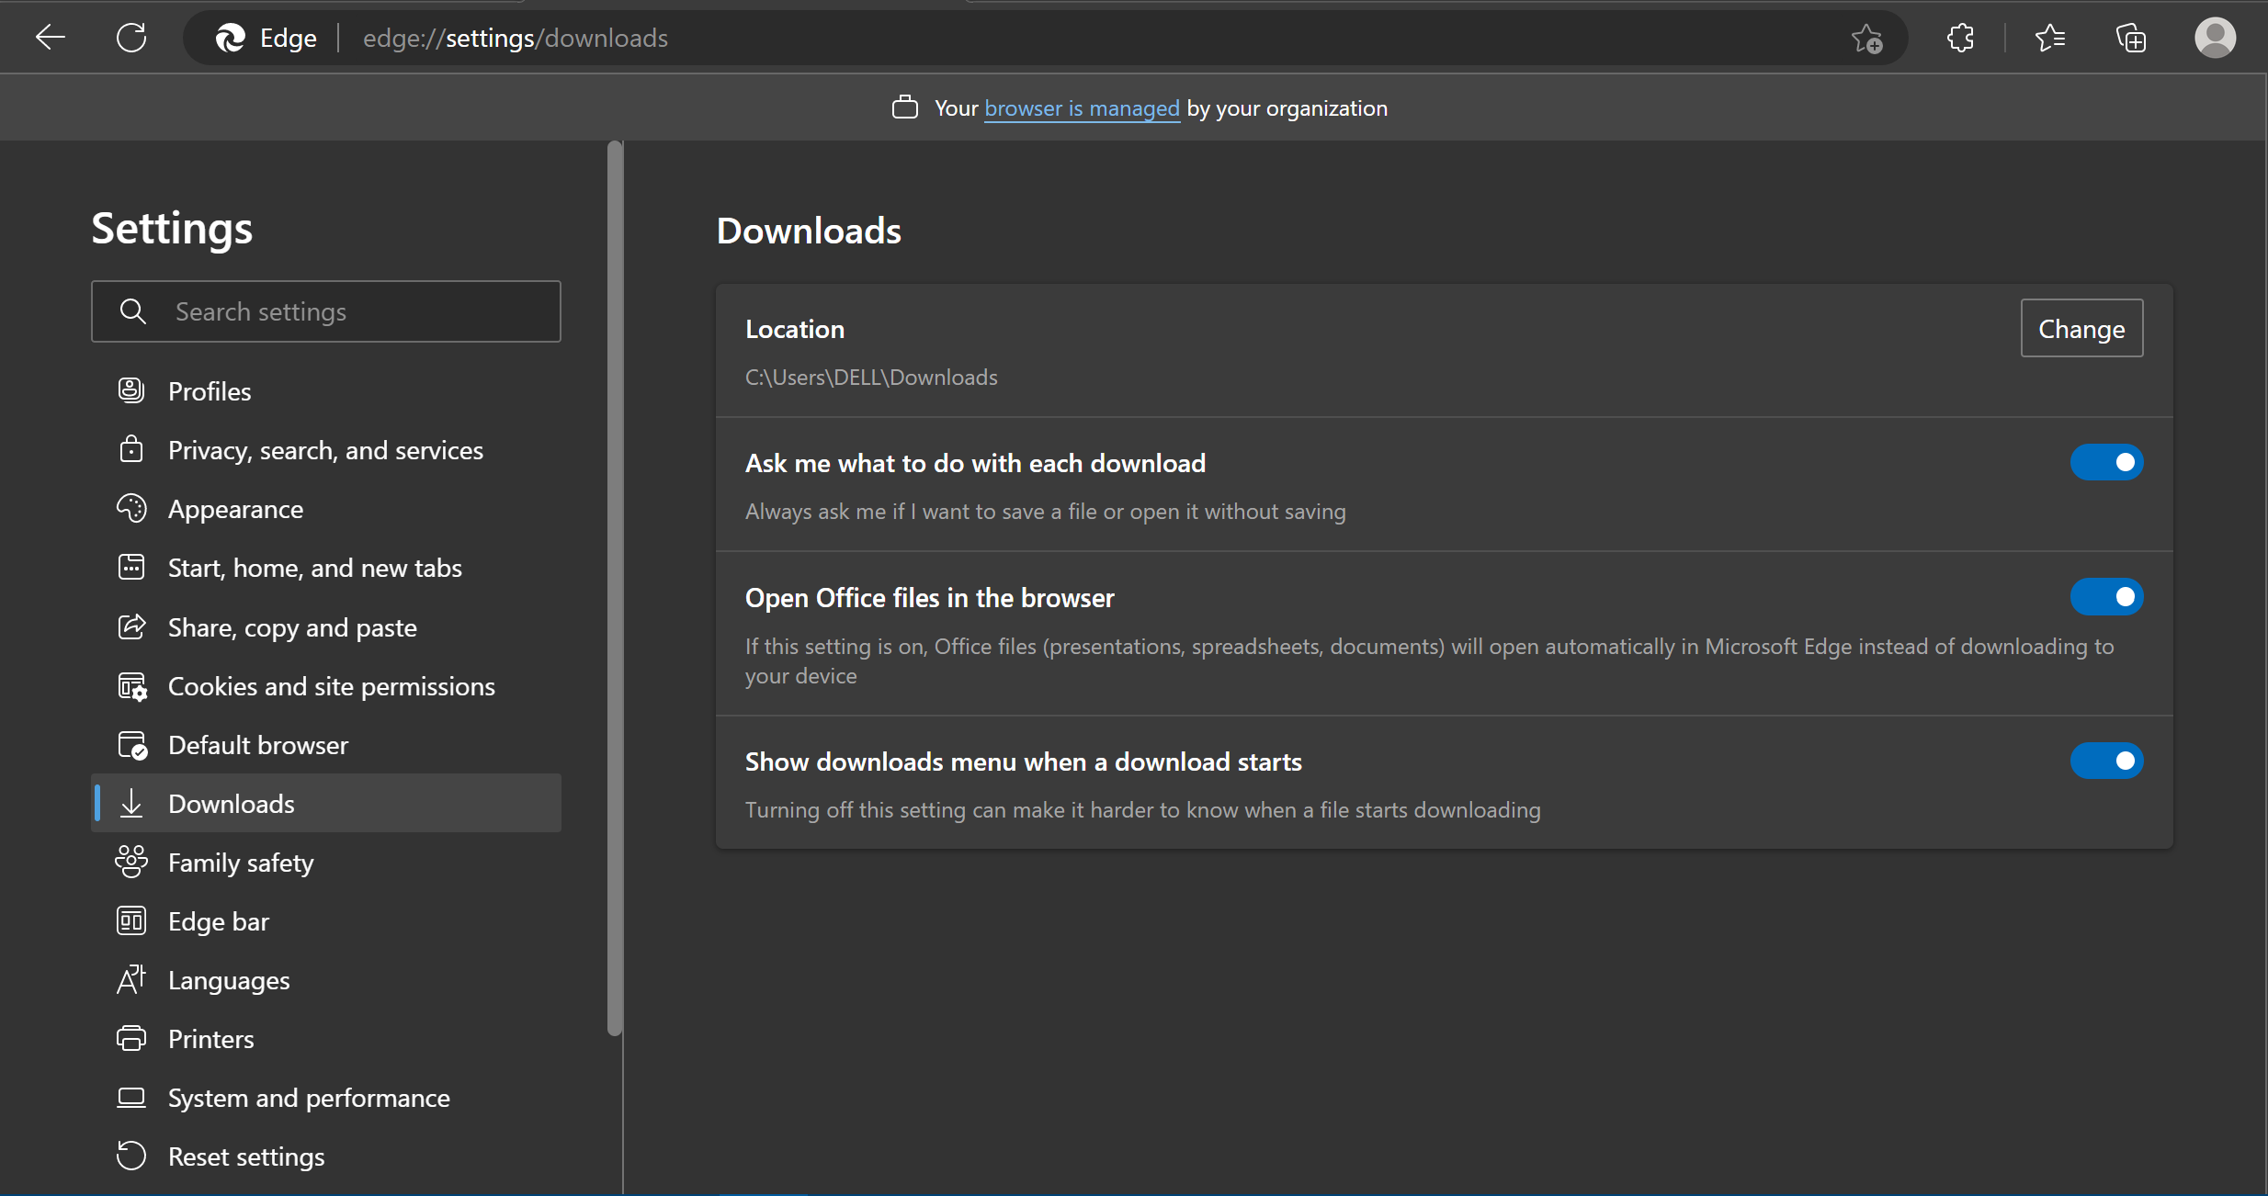

1. In Settings >Cookies and site permissions > Pop-ups and redirects

Add the site where pop up needs to be allowed.

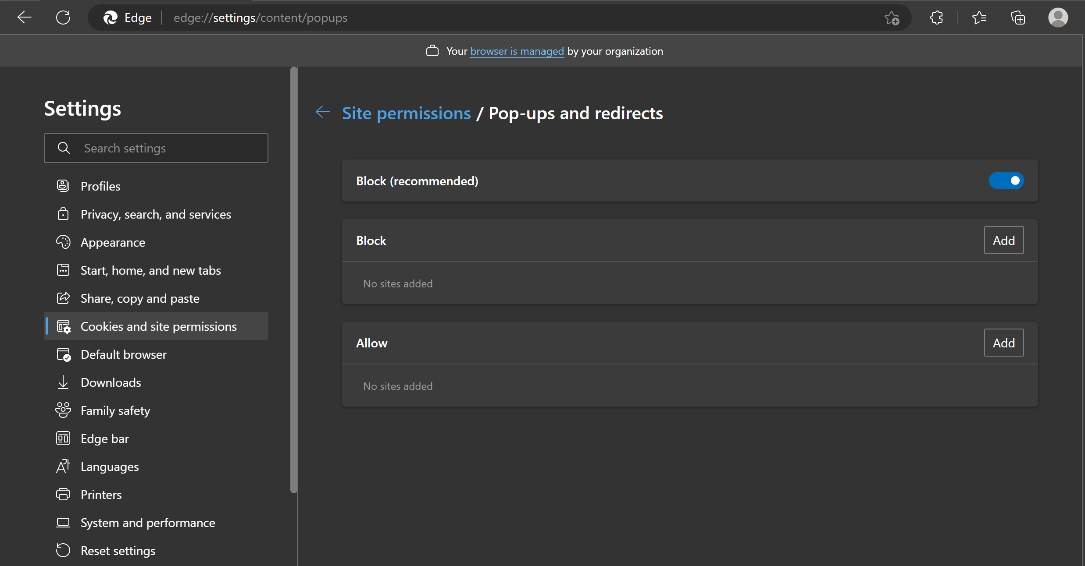

**MS Outlook**

1. **Ms Outlook must be installed and configured in the machine.**

# Orchestrator

## Orchestrator Assets

**How to add and update credentials in UiPath Credentials**

1. Creating Assets
2. Graphical user interface, application

   Description automatically generatedIn the Assets page, click Add.
3. The Add Asset window is displayed.

1. In the Asset name field, enter a name for the asset.
2. From the Type list, select the type of asset you want to create.
3. (Optional) Add a Description of the asset.
4. Use the Add button to create the per user asset values desired.
5. Click Create. The asset is created and displayed on the Assets page.
6. To update the credentials, click on edit as shown

1. Update the password and click on update

# How to run the bot

1. 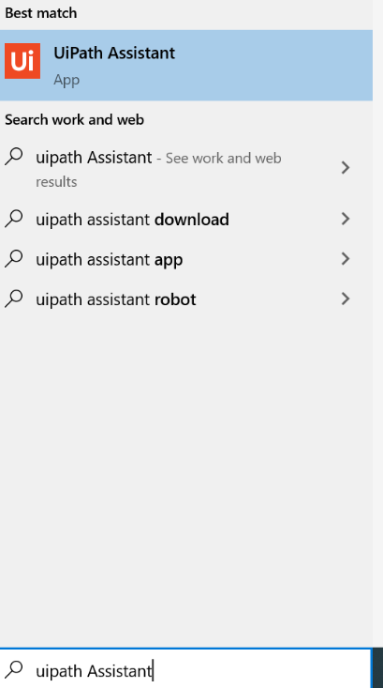Open the UiPath Assistant Application
2. If it is the 1st time. You will get the below screen -

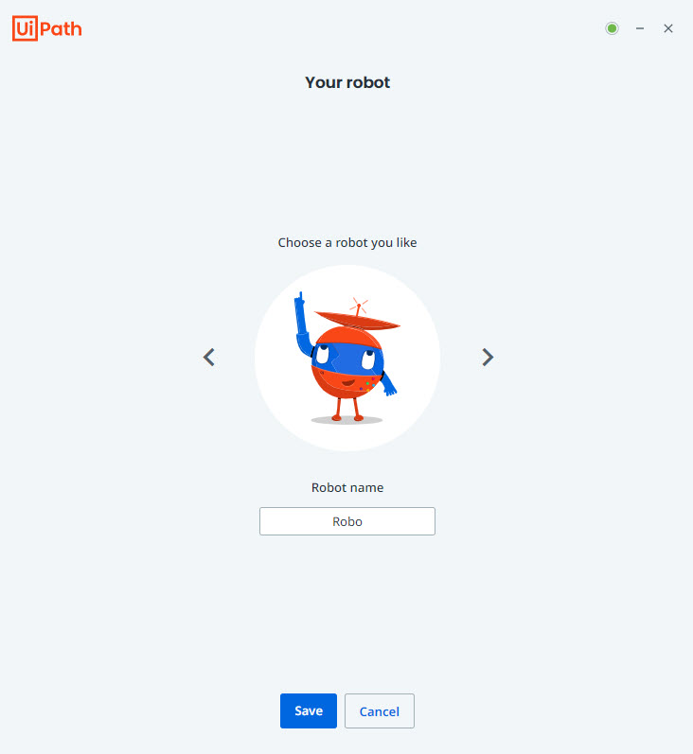

Add any name for the robot and click on – ‘Save’ or ‘Get Started’ button.

1. Start the Process from the Home page as shown.

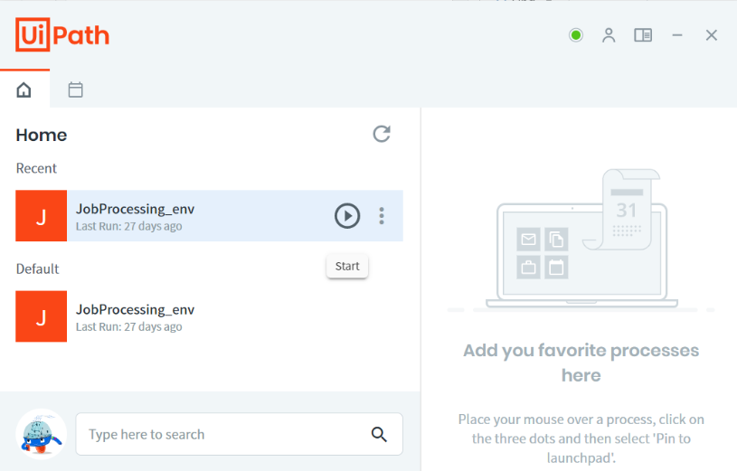

1. Bot Starts Executing.

# Bot Configuration File

Table below explains the keywords given in the configuration file:

|  |  |
| --- | --- |
|  | |
| logF_BusinessProcessName | Logging field which allows grouping of log data of two or more subprocesses under the same business process name |
| Error_Mail_Receiver | Provide Email IDs of persons who should receive Email when an Exception occurs during the execution of the Bot. Email IDs should be seperated by ';' example: abc@xyz.com; pqr@xyz.com |
| Error_CC_Mail_Receiver | Provide Email IDs of persons who should be added to CC in receiving the Email sent when an Exception occurs during the execution of the Bot. Email IDs should be seperated by ';' example: abc@xyz.com;pqr@xyz.com |
| Success_Mail_Receiver | Provide Email IDs of persons who should receive the Status of Bot Execution Email. Email IDs should be seperated by ';' example: abc@xyz.com;pqr@xyz.com |
| Success_CC_Mail_Receiver | Provide Email IDs of persons who should be added to CC in receiving the Status of Bot Execution Email. Email IDs should be seperated by ';' example: abc@xyz.com;pqr@xyz.com |
| InputFolder | Complete Input Folder path |
| OutputFolder | Output Folder path |
| ExScreenshotsFolderPath | Error Screenshots folder path |
| UserInputFolder | The User Input folder where the user places the input files |
| TempFolder | The Temp folder which the bot uses to perform the process |
| ICORE_URL | URL of the ICORE portal |
| In_NonWorkingDayFile | The day of the month when bot should not work |
| Col_AccountID | Column AccountID |
| Col_StartDate | Column Start Date |
| Col_EndDate | Column End Date |
| Col_TranDate | Column Tran Date |
| Col_ValueDate | Column Value Date |
| Col_instrNo | Column Instr No |
| Col_Particulars | Column Particulars |
| Col_CCY | Column CCY |
| Col_DebitAmt | Column Debit Amount |
| Col_CreditAmt | Column Credit Amount |
| Col_Bal | Column Bal. |
| Col_Status | Column Status |
| Name_FINCORE | FINCORE |
| Name_HACLINQ | HACLINQ |
| MaxRetryNumber | If >0, the robot will retry the same transaction which failed with a system exception. Must be an integer value |
| LogMessage_GetTransactionData | Static part of logging message. Calling Get Transaction Data |
| LogMessage_GetTransactionDataError | Static part of logging message. Error retrieving Transaction Data |
| LogMessage_Success | Static part of logging message. Processed Transaction Successful. |
| LogMessage_BusinessRuleException | Static part of logging message. Processed Transaction Failed with business exception. |
| LogMessage_ApplicationException | Static part of logging message. Processed Transaction Failed with application exception. |

# Files in Shared Folder

1. Input folder structure:

Contains all the input files previously provided by the users. Here N = number

The folder path is <YYYY>\<MM>\<DD.MM.YYYY>\N_InputToday\

1. UserInput folder structure:

Contains all the input files which will be placed by user

1. Output folder structure:

Contains all the outputs generated by the bot.

The folder path is <YYYY>\<MM>\<DD.MM.YYYY>\Account_ID

1. Temp folder structure:

Contains the Temporary Files generated during the execution of the Bot. They will be deleted at the end of each execution

1. Error Screenshot folder structure:
   1. ExceptionScreenshot_yyMMdd.hhmmss.png

Error screenshot files are stored in this directory with Date Time stamp

1. Configuration folder structure:
   1. Config.xlsx

Excel file contains all the configuration details related to Shared folder path, Mail ID’s, Asset names and Constants used for Bot configuration.

# Check for the input files

1. Bot determines whether the manual input file which is placed by user is present in the input folder
2. If the file is missing in input folder then an email is send and the bot terminates the process

# Logging in to ICore Portal

1. Picks the credential from Orchestrator Assets
2. Opens ICore Portal URL in edge
3. Enters username, password and allow user to enter the OTP.
4. Clicks login button
5. Checks if login is successful.
6. If login is failed Bot takes the screenshot and shares the exception details to exception receiver in To and CC.

# Extracting the details from Icore using “HACLINQ” Code

1. Bot picks the Path from Config file and logs in to ICore Portal.
2. Read the file which is placed by the user in the User Input Folder and place it in Input folder.
3. Select the solution as “FINCORE”.
4. For each row in the input file, enter the code “HACLINQ” and click on “GO”.
5. Enter the “Account ID”, “Start Date” and “End Date” and click on “GO”.
6. Then copy all the transaction details of each page into the output file.

# Send Outlook Mail

1. Bot checks for all the input files are present in input folder if not send an email
2. Send an email if unable to download the dump files
3. Send an email for every Account ID, after successful process completion.
4. Process completion email is sent to the Process owner along with the status of each Account ID

# Known Issues

**Trouble Shooter**

* + - 1. Make sure to enter the custom date in the given format.
      2. Use the prescribed format for the input file names.
      3. If Portals are down and applications are not working clear the browsing history, temp files in the system and restart the machine.
      4. If wrong password is retried more than 3 times accounts get locked, raise SR and unlock the account.
      5. If the screensaver is not disabled bot execution stops and take administrator access and disable the lock screen and screensaver.
      6. If shared folder space is full and bot is not able to store the files in the output folder remove the old data in directory or extend the shared drive space.
      7. Do not delete or manipulate the files in the “Templates” folder